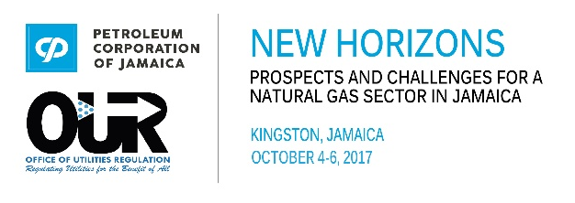
Registration Form
Inaugural Jamaica Natural Gas Conference 2017

Please complete this form and return to Secretariat by July 31, 2017 to info@jamaicagasconference.com.
Name of Organization:
Address: | Country
Name of Contact Person: | Tel. # | E-mail:

Kindly accept registration for the following persons:
Name | Job Title | Telephone | E-mail address
Registration Rates
Early Bird US$225 (ends August 31, 2017) All Conference Days US$275
Daily rate US$175
- Wednesday October 4, 2017 (Kingston)
- Thursday, October 5, 2017 (Kingston)
- Friday, October 6, 2017 (Montego Bay)
Please indicate which day(s) you will be in attendance:
Method of Payment
Cheque – Make payable to PETROLEUM CORPORATION OF JAMAICA
International Wire Instructions
SWIFT Message Type- MT103 (Payment Order/Advice)
Bank Name: Bank of New York Mellon, New York
ABA Routing#: 021000018
SWIFT Code: IRVTUS3N
Credit Card
Wire Transfer

Local banking information:
Account Name: National Commercial Bank Jamaica Limited
Branch: Knutsford Boulevard
NCB Bank’s Address: 1 – 7 Knutsford Boulevard, Kingston 5.
Account Name: Petroleum Corporation of Jamaica
JMD Account #: 352434108
SWIFT Code: JNCBJMKX
Branch: Cross Roads | Branch Code: 023
NCB Bank’s Address: 90 – 94 Slipe Road, Kingston 5.
A/C #: 8033407727
SWIFT Code: JNCBJMKX
Either
For Further Credit to: Petroleum Corporation of Jamaica
Account #: 236572803
Direct Deposit

Please include “JAGAS2017” in the transaction so it can be easily identified.

Applicants will be refunded 50% of total fee paid, if their written notice of cancellation is seven (7) working days prior to the date of the conference. No refunds will be made after this period.

