OFFICE OF UTILITIES REGULATION INFORMATION CENTRE (OURIC)
NEWSLETTER STORY
LIBRARY WEEK 2022

#discoverOURIC

It seems like only yesterday that we were designing ads, social media messaging and slide shows, preparing scripts for radio interviews and video productions and forging partnerships with Library stakeholders for various activities and events. These were the activities of Library Week 2022, which went the way it arrived, with enthusiasm and fervour bridled only by competing events that did little to threaten its impact.
It all happened in one short week, but it was a resounding success. Another Library Week had come and gone and left in its wake new opportunities for growth and development of the Office of Utilities Regulation’s Information Centre (OURIC).
Celebrated 2022 October 30 to November 4 with a range of activities under the theme GLAM/Rs – Galleries, Libraries, Archives, Museums, Records Centres - Re-ignited for Greatness,” OURIC used the opportunity to continue its public education efforts centred around the hashtag - “discoverOURIC”.
“#discover OURIC” meant just that. Getting to Know the OUR’s Information Centre - its mandate, purpose, as well as both manual and digital resources and services offered. The impact of this promotion would be far-reaching, requiring that several strategies be undertaken with the aim of conveying that all-important message - that a utilities regulatory library does exist, with the capacity to fulfil the needs of its target audiences, which includes regional regulators, tertiary-level institutions, high school students and others.
To get this message across this year would mean OURIC’s participation in an outreach activity hosted by the Kingston and St. Andrew Parish Library (KSAPL) on 2022 November 4, the goal being that of heightening awareness about, and support for the OURIC brand, thus building a brand reputation among external stakeholders. This event which targeted high school students and teachers of Robotics was a convergence of students, teachers, and library patrons in one space. It therefore presented a grand opportunity for one-on-one/group interactions with potential OURIC users and the imparting of critical knowledge about OURIC’s products and services from a small booth space, the use of which was maximised with the running of an electronic slide show, the hosting of pop trivia to students, a display of OUR’s print materials including books and promotional flyers, and a mounted display of “The OURIC Story”. Office of Utilities Regulation (OUR) memorabilia and souvenirs were awarded to Trivia winners.
A custom-made selfie frame was perhaps the most unique feature of the event as it served to bolster support for the OURIC brand in a fun and interactive way. This was an effective strategy for visual marketing, attracting the attention of primarily students and teachers.
The success of this event although far-reaching, however, did not overshadow the impact of another significant activity on OURIC’s Library Week calendar, that being OURIC’s “Get the Facts”, YouTube video production. In the first week post-Library Week, the video had a live viewership of over 85 and counting. The production provided insight into the digital transformation journey that the Information Centre had successfully embarked on four (4) years before. Little wonder then that it was also a crowning achievement.
Also top-tier was OURIC’s representation on mainstream media through the OUR’s radio programmes - Call the OUR (CTO) aired live, on Radio Jamaica, and Inside the OUR (ITO), recorded for Nationwide News Network. With a planned outreach activity and video production this was really just “icing on a well-made cake”.
Other features included advertising in the Library and Information Association of Jamaica’s (LIAJA) Gleaner supplement; social media messaging and internal activities for OUR staff. These activities gave OURIC the promotional push that was needed, in a marketing campaign that will continue well beyond Library Week celebrations in the future.
The targeted audiences reached by these efforts were:
  - OUR staff members,
  - Tertiary-level institutions,
  - High school students and teachers,
  - Library Associations,
  - Ministries and agencies, and
  - Regional partners.

With such a successful 2022 campaign the future looks bright for Library Week celebrations to come.
By – Colleen Mignott
Information Officer (OURIC)

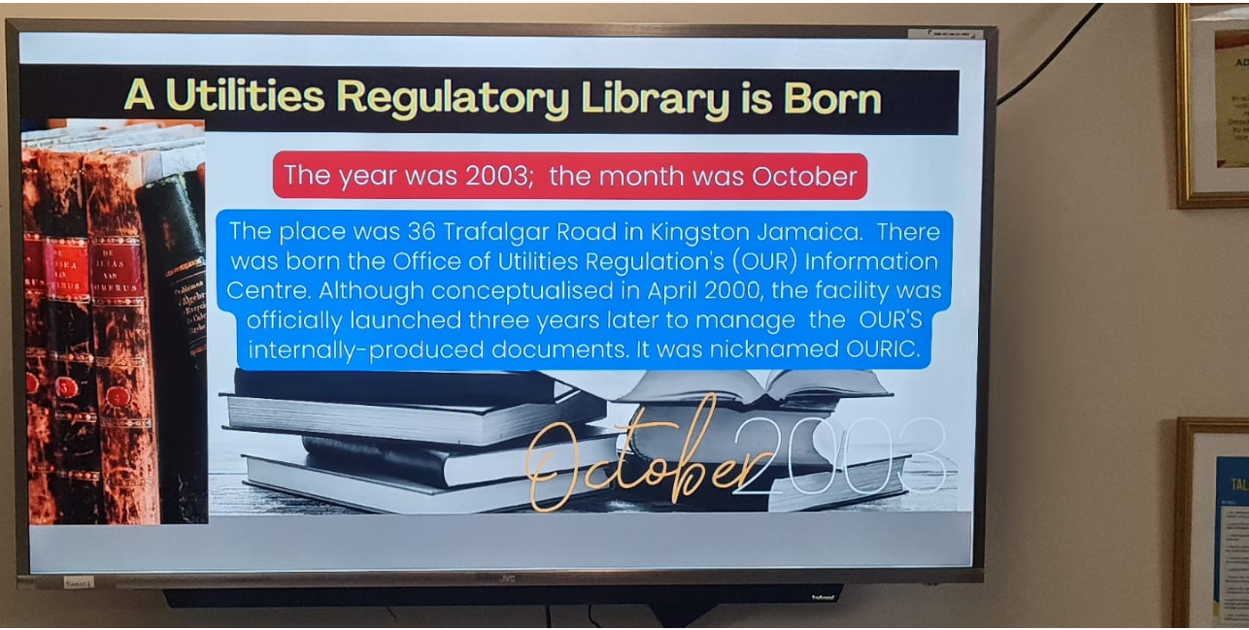
Figure 1 – A slide from exhibition as it ran in OUR’s reception area during Library Week 2022

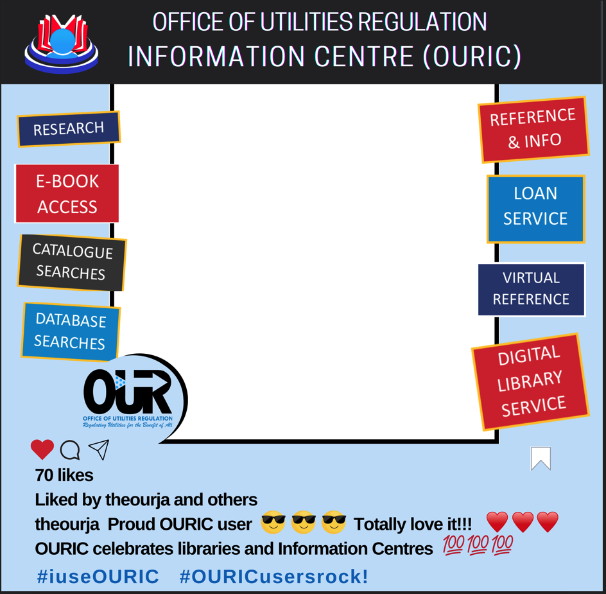
Figure 5 – Promotional photobooth design

PICTORIAL
The below pictorial captures some of the defining moments of the #discoverOURIC campaign at the Jamaica Library Service/KSAPL outreach activity on Friday, Nov 4. The photo frame prop designed by OURIC was the centrepiece of this event.
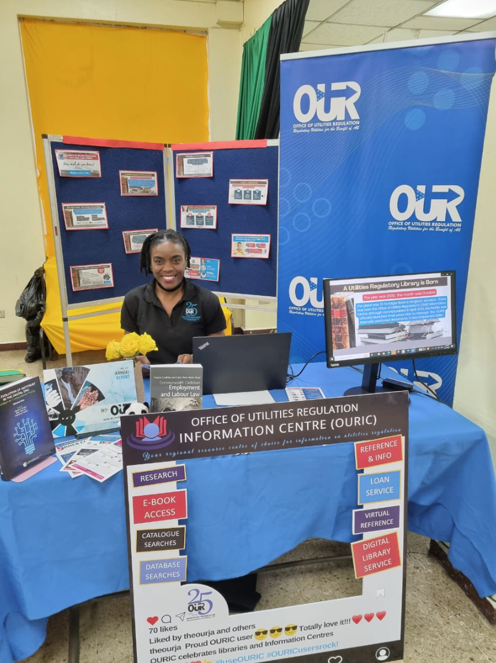 | 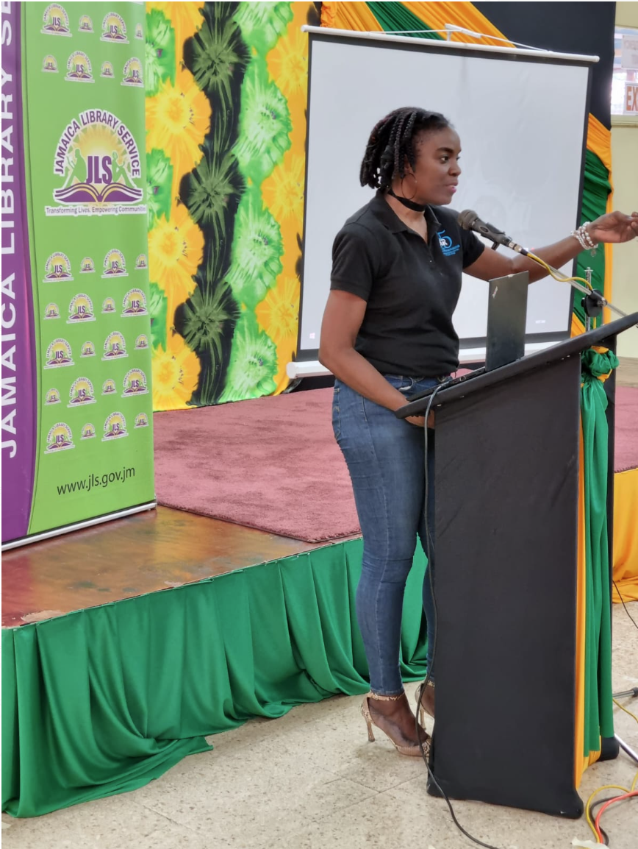 | 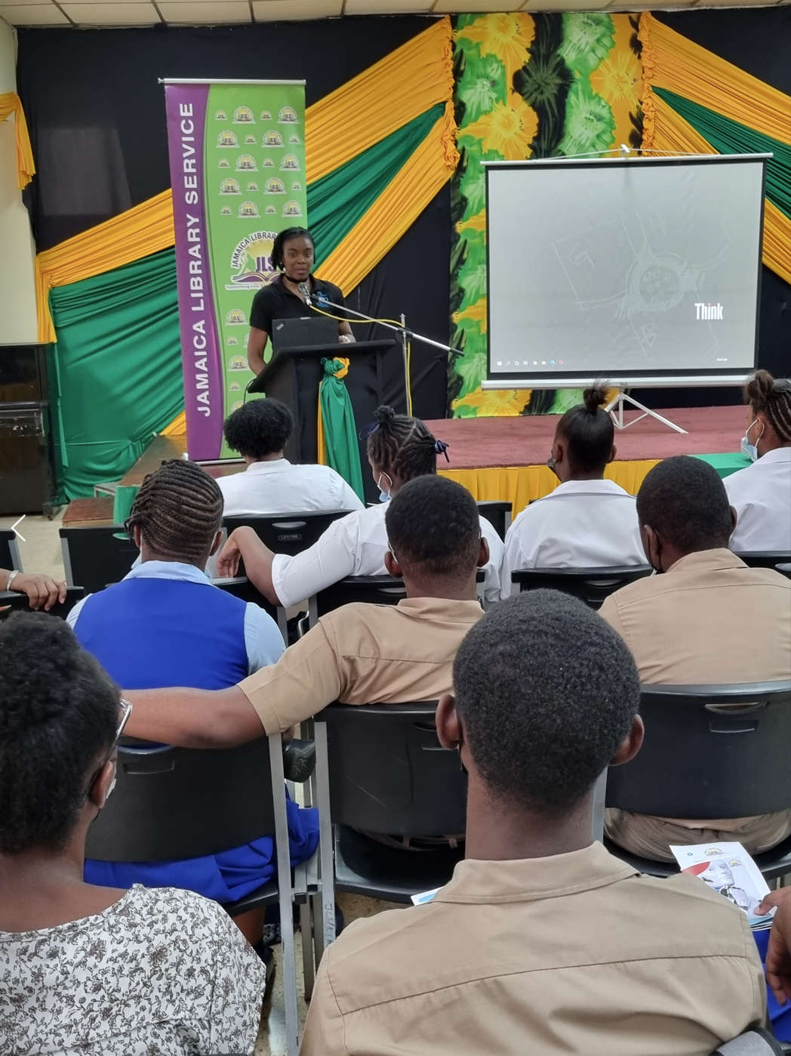
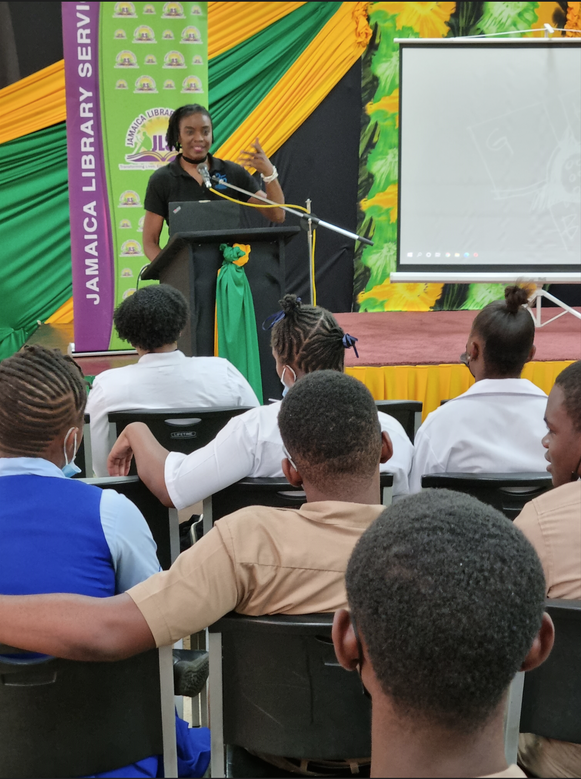 | 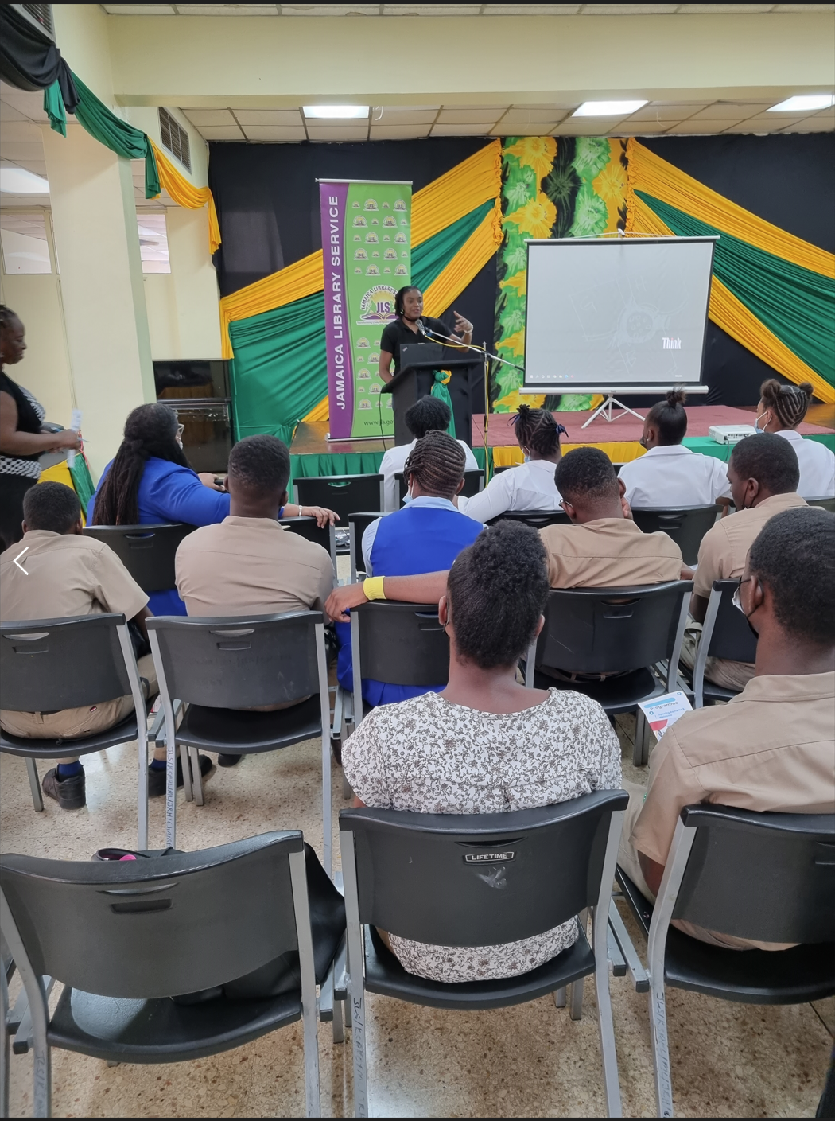 | 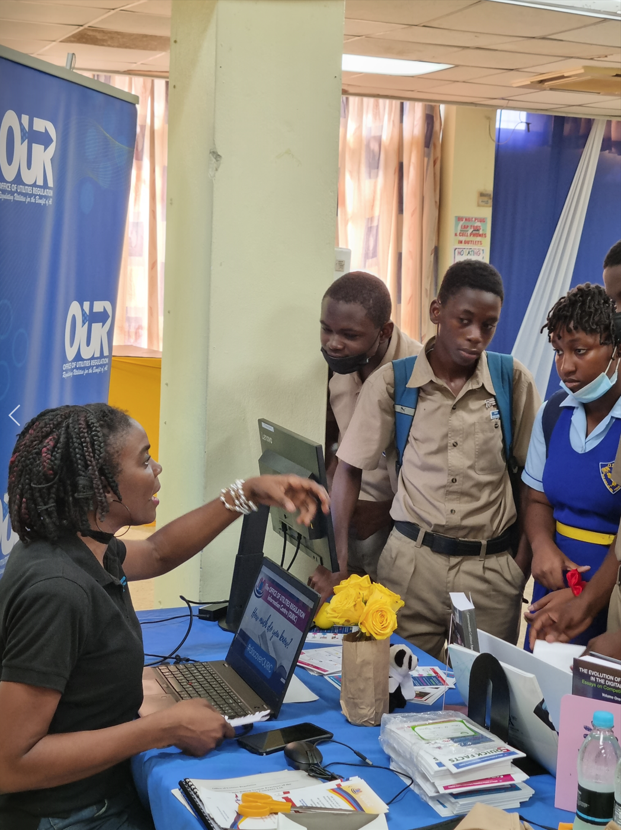
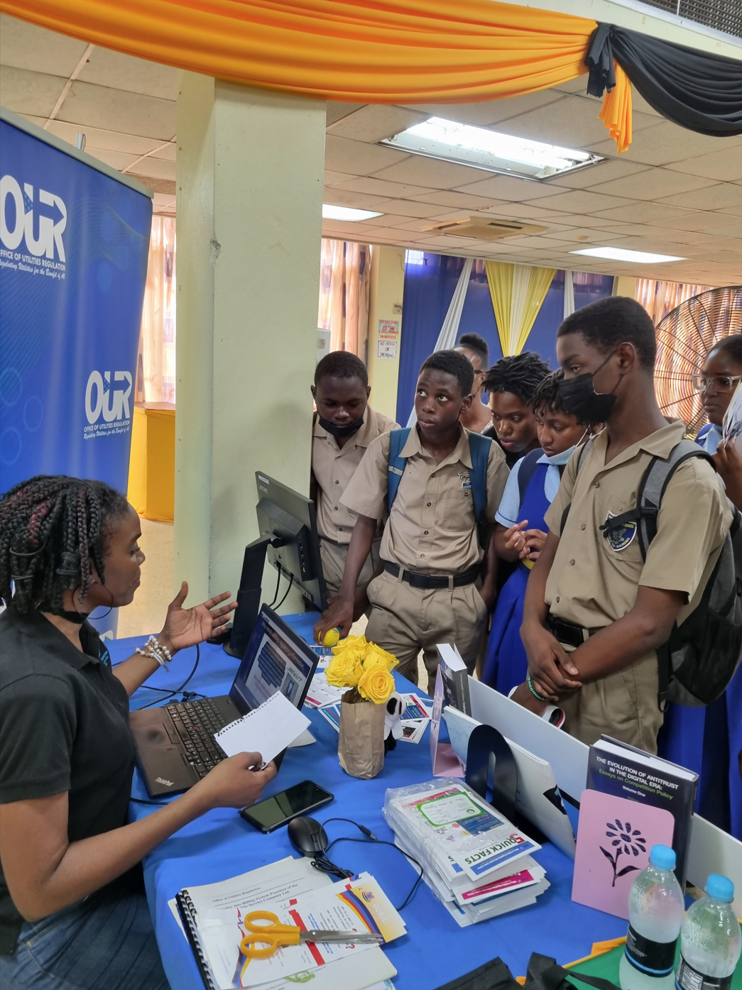 | 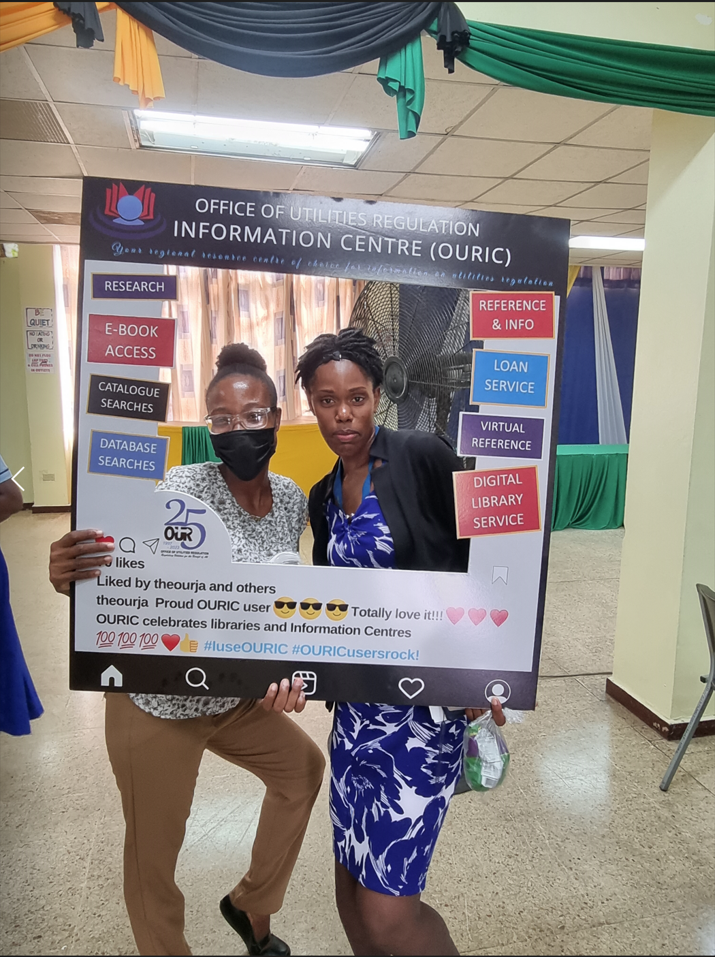 | 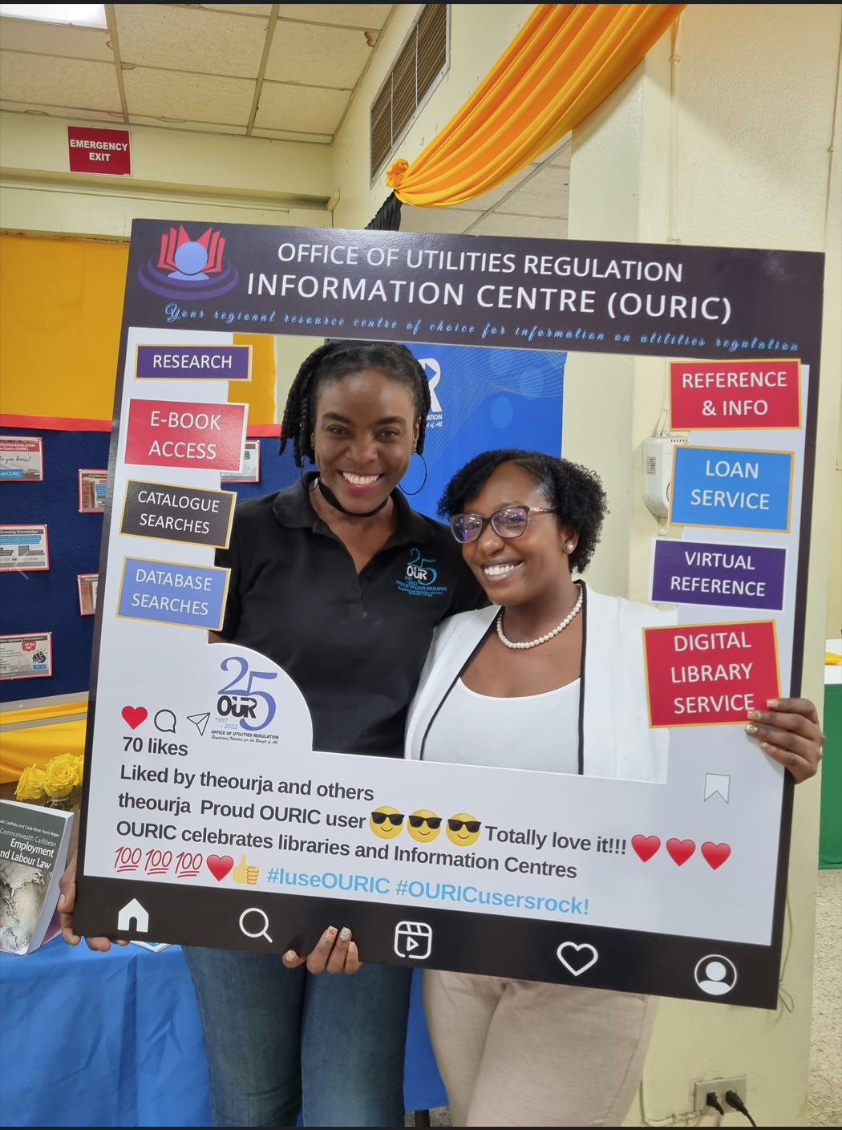
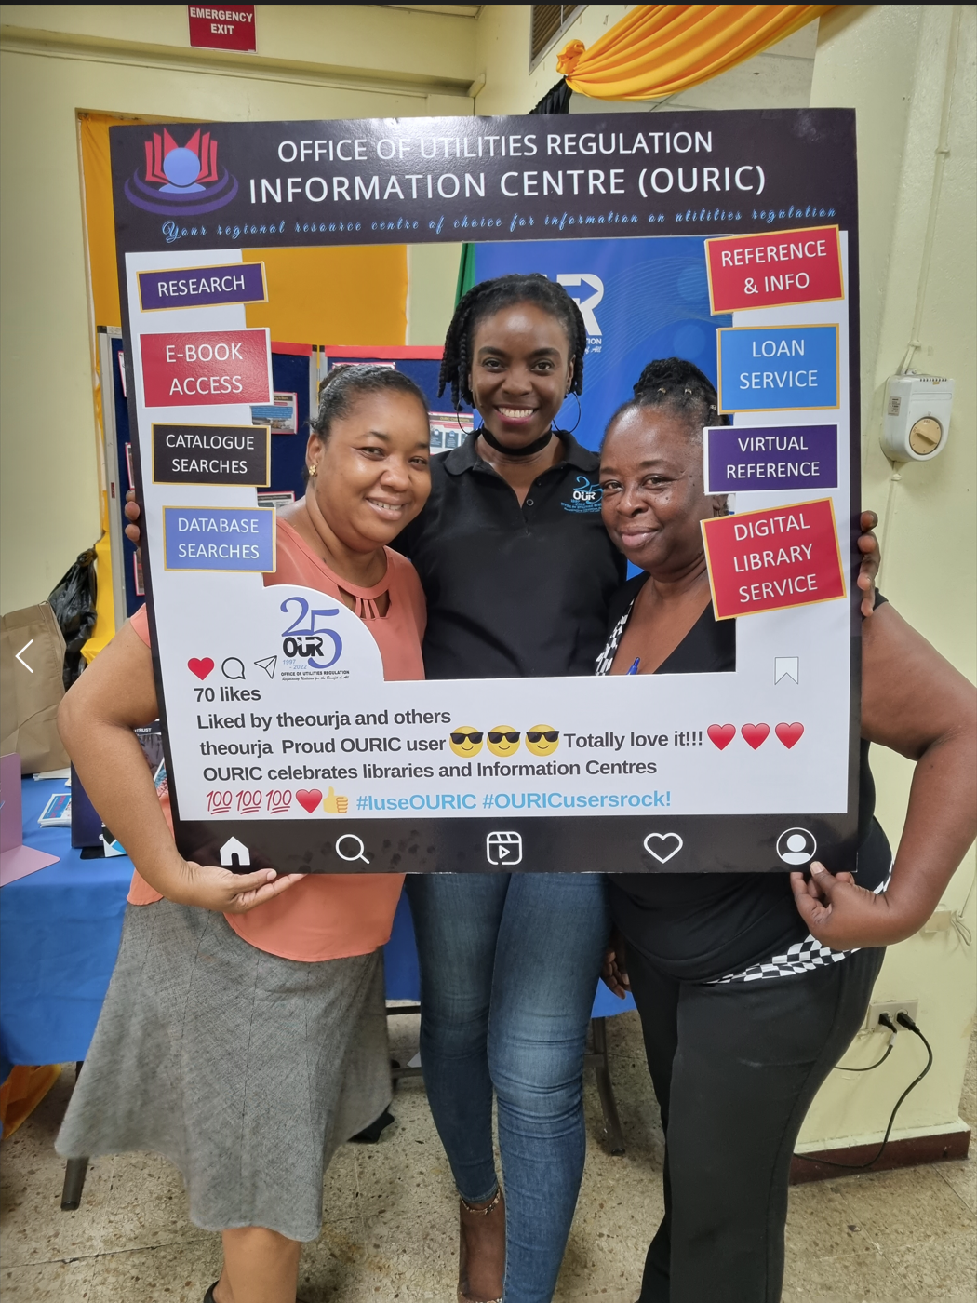 | 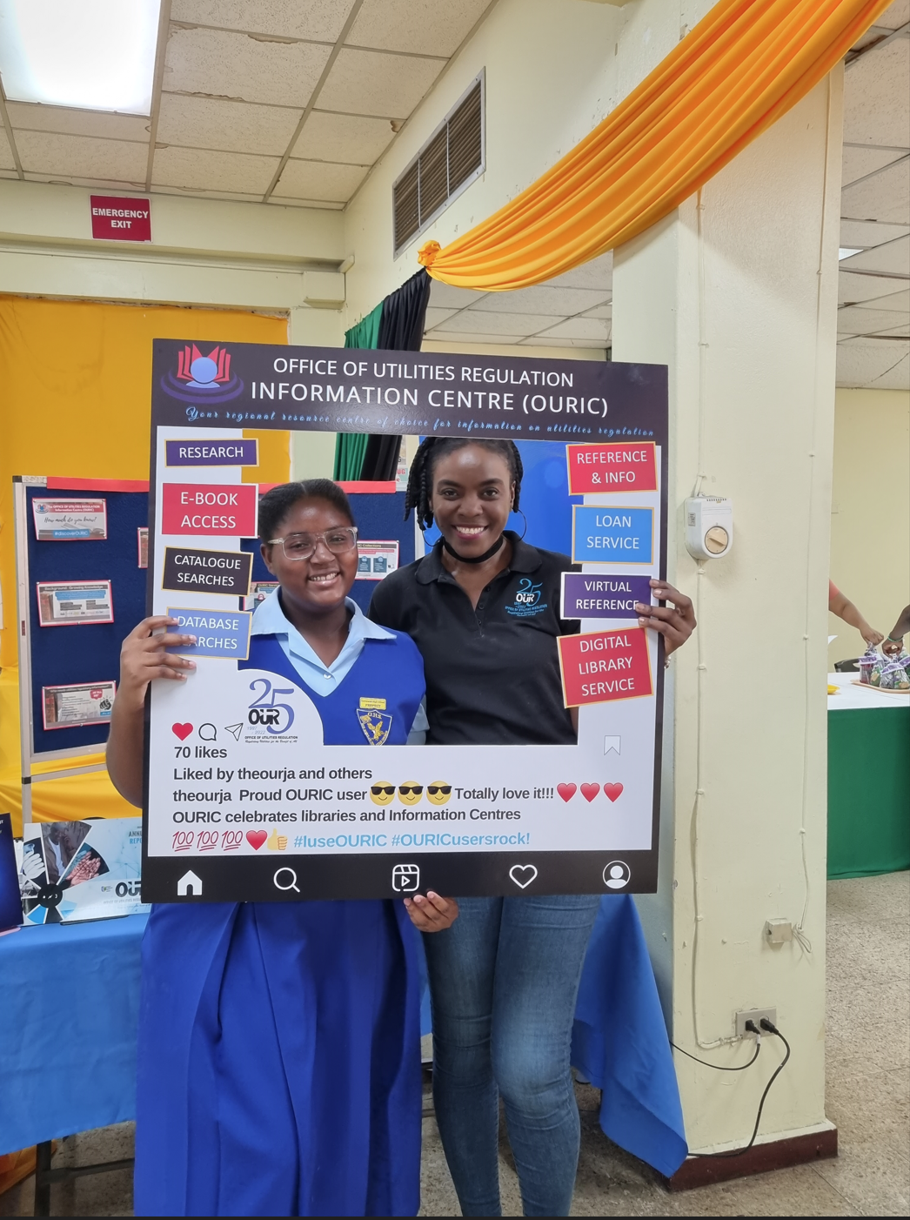 | 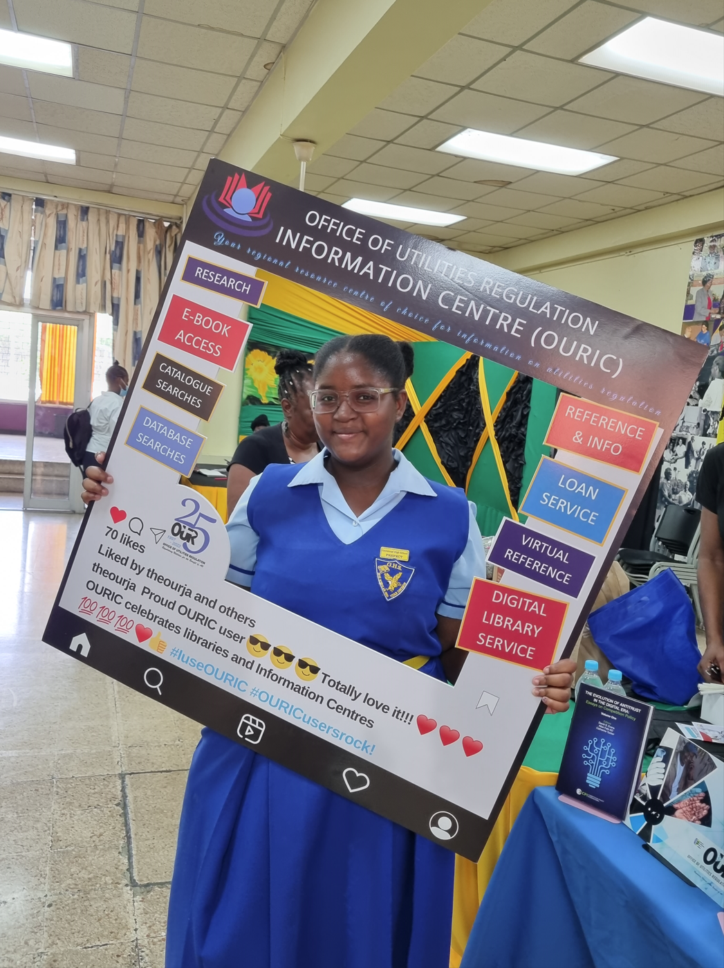
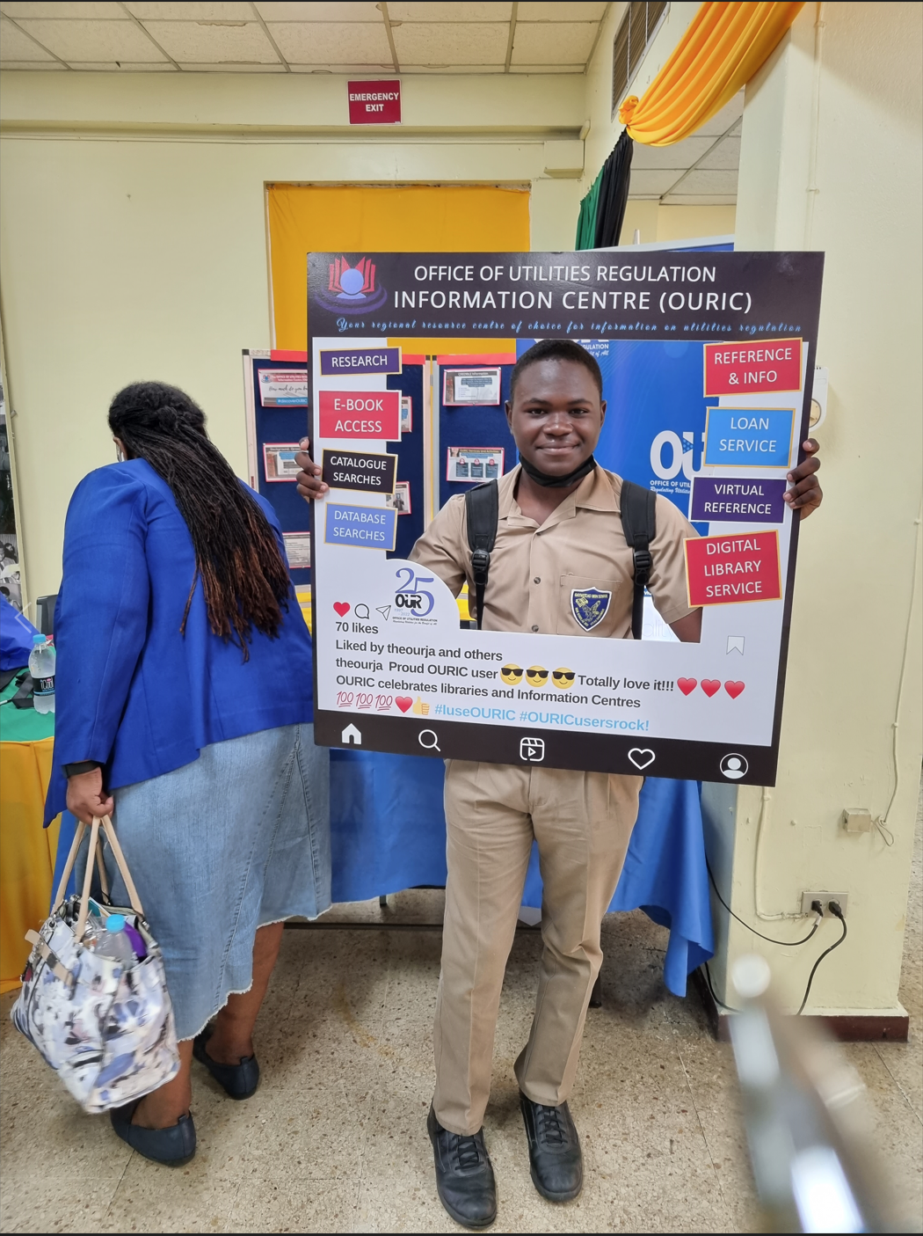 | 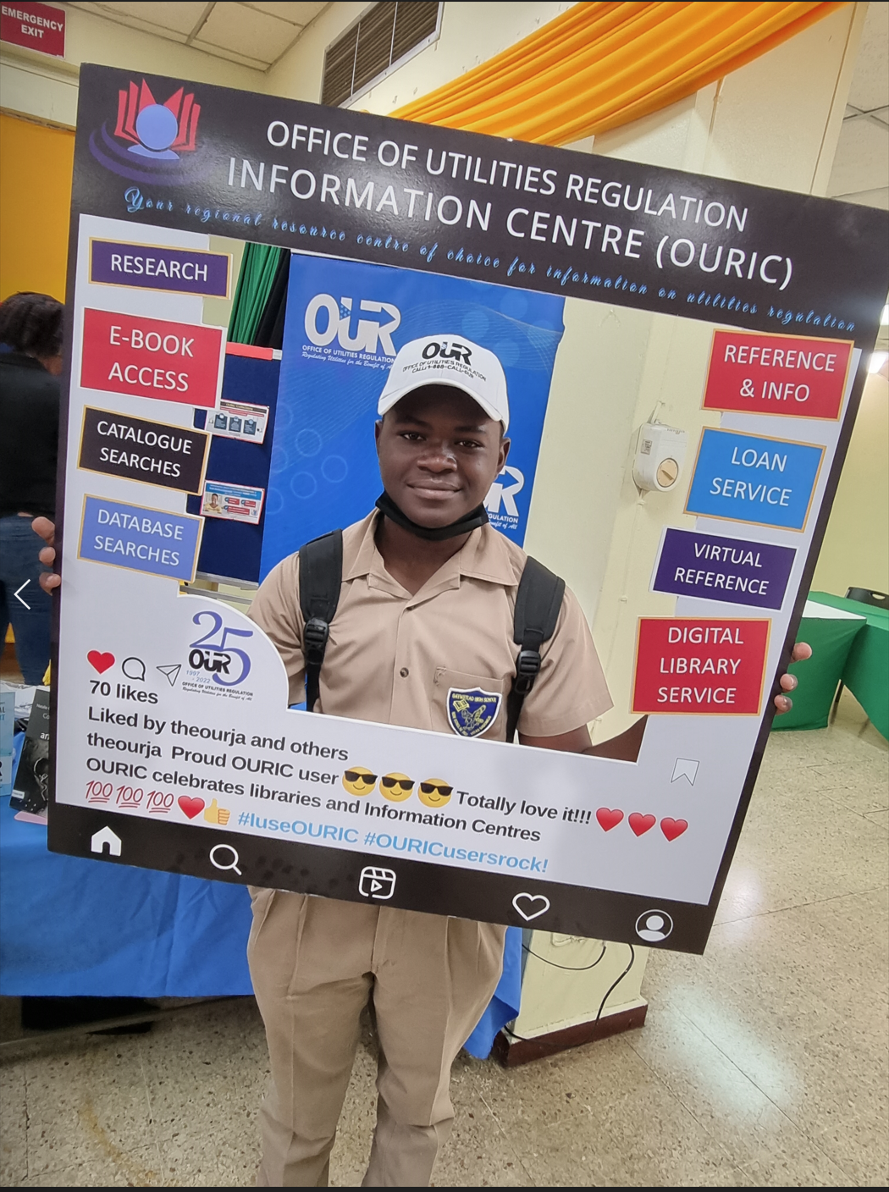 | 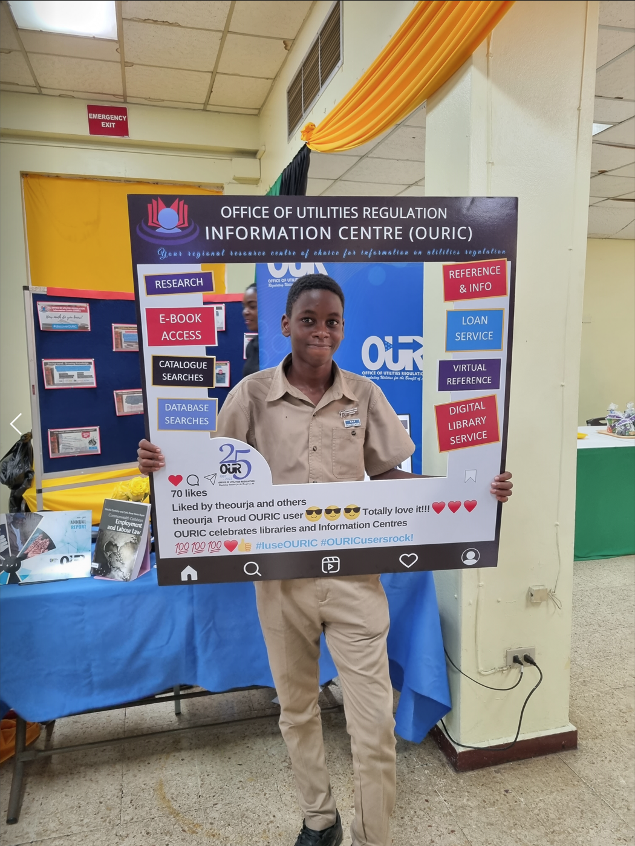
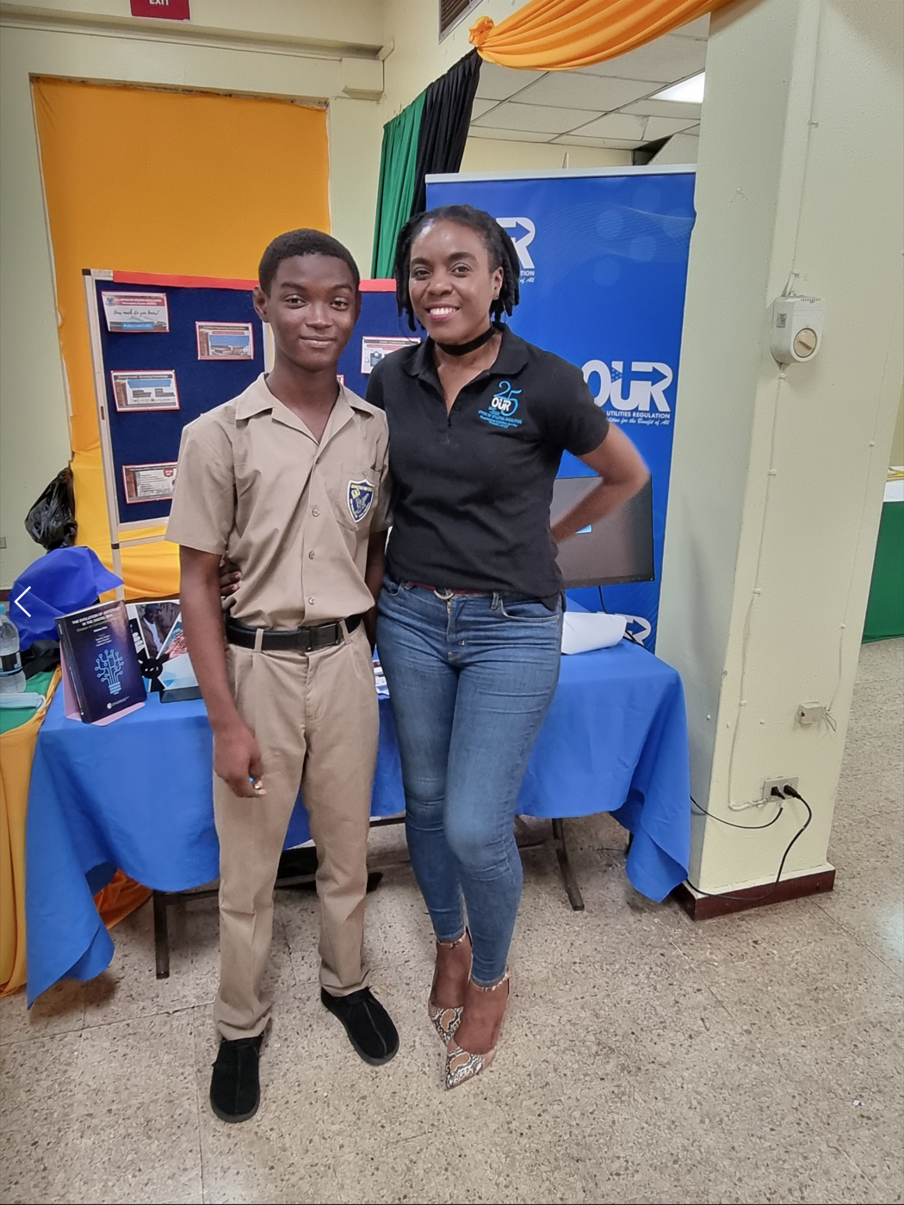 | 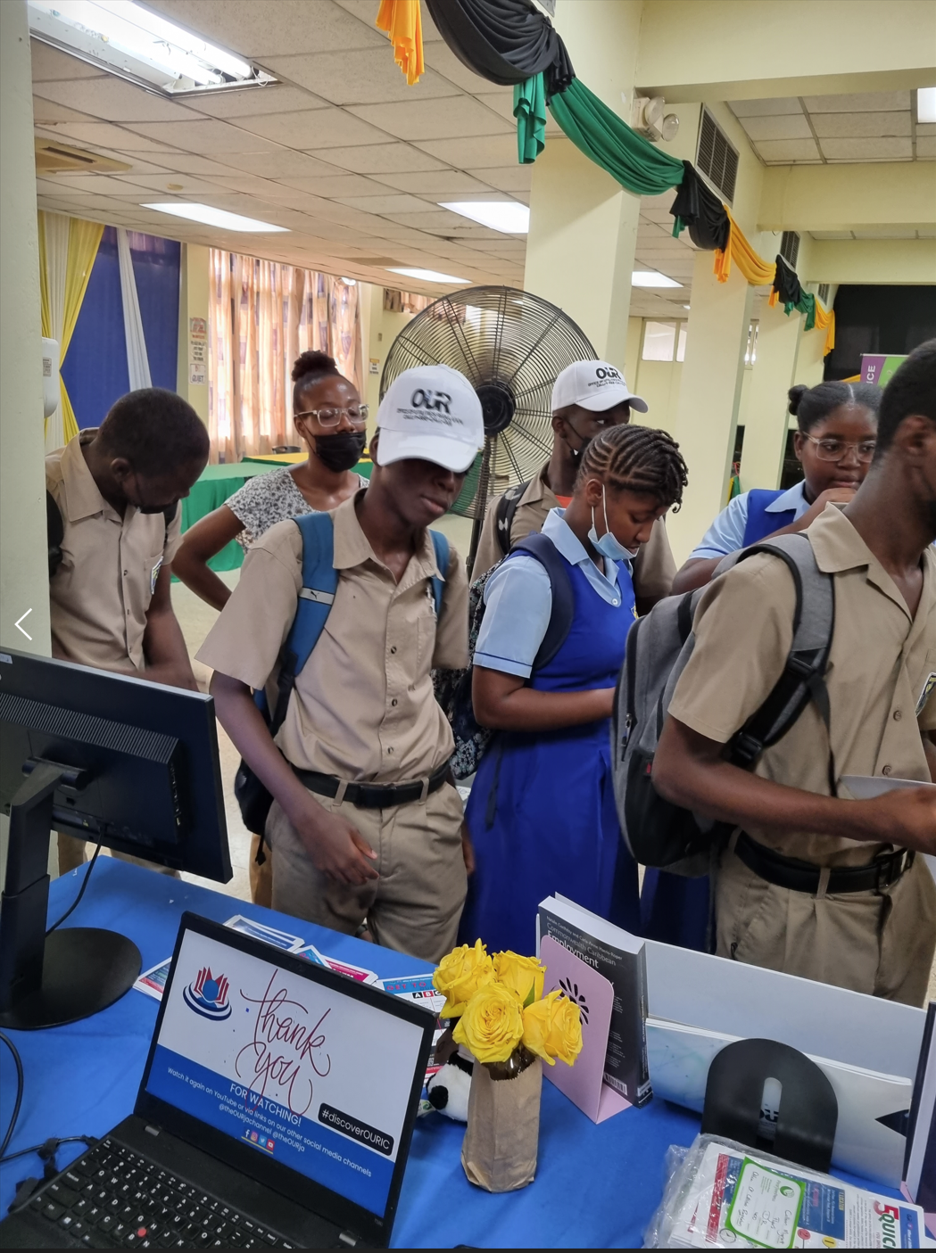 | 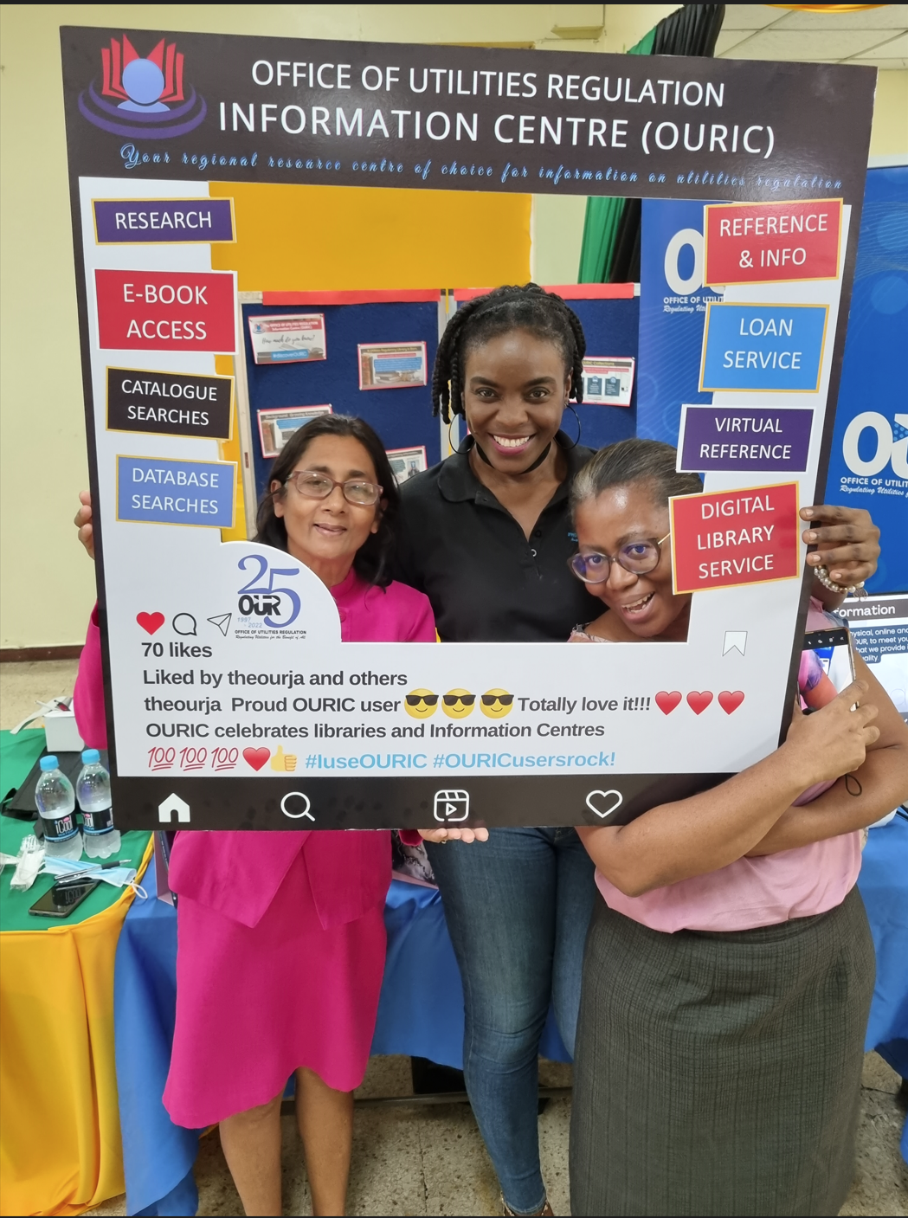
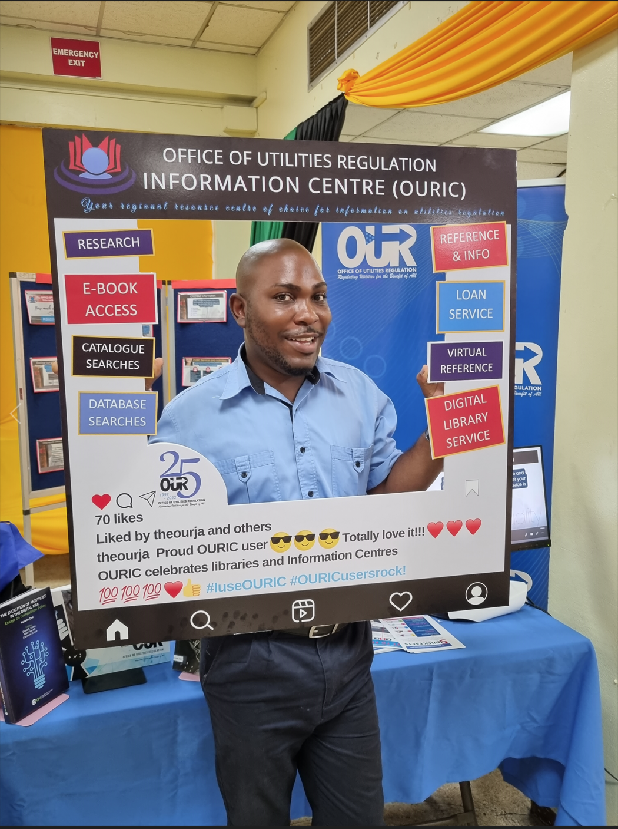 | 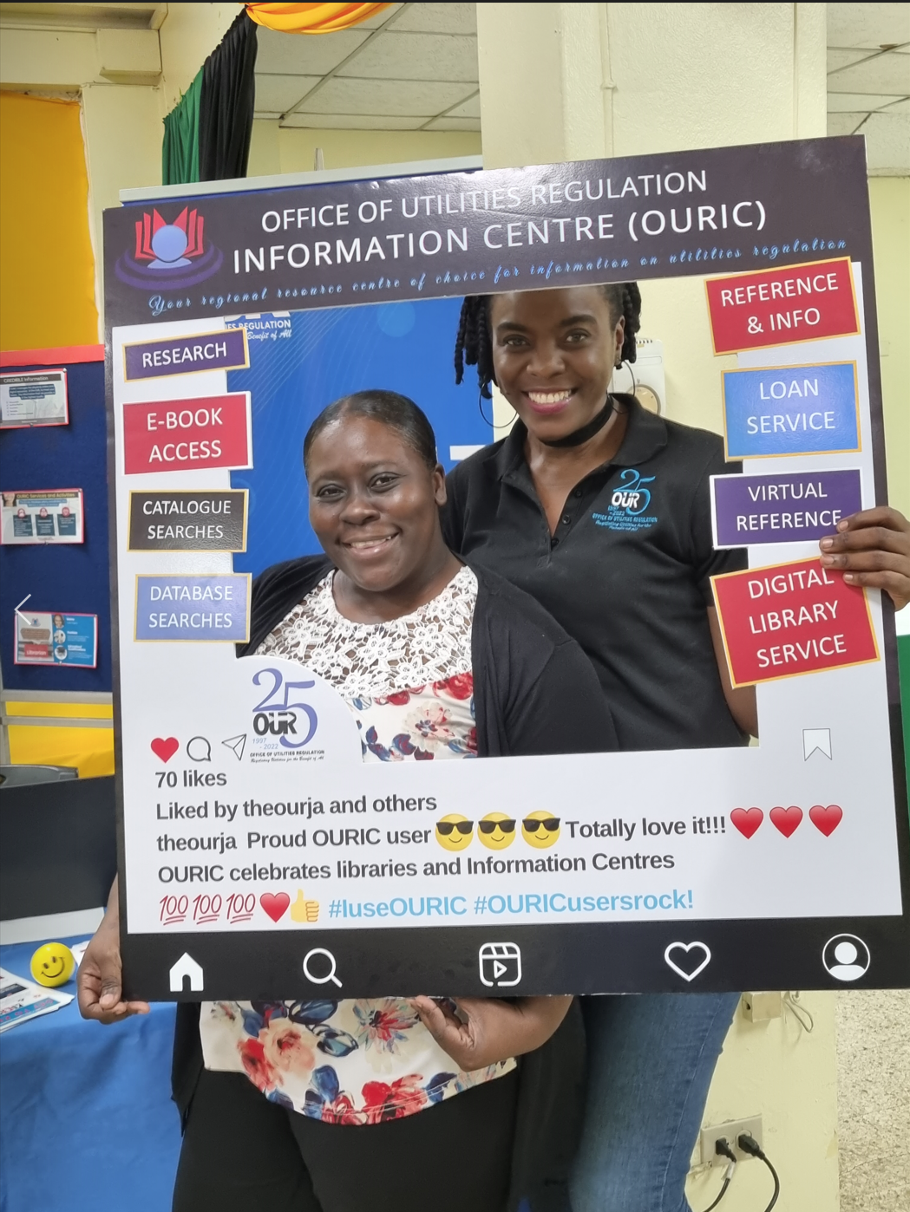 | 